**VelammalCollege of Engineering and Technology, Madurai**

**Department of Computer Science and Engineering**

**21CS205 - Object oriented programming lab**

**Exercise** 3

Inheritance

Team 1

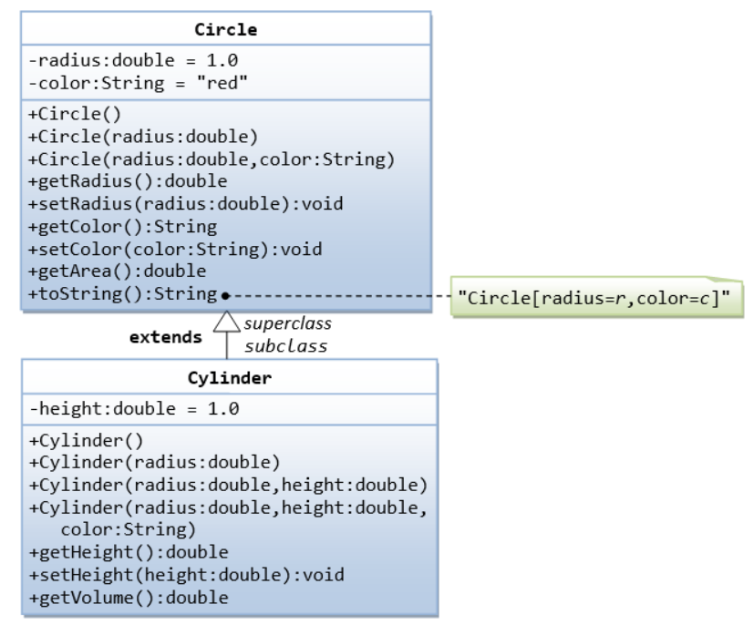

In this exercise, a subclass called Cylinder is derived from the superclass Circle as shown in the class diagram. The subclass Cylinder invokes the superclass' constructors (via super() and super(radius)) and inherits the variables and methods from the superclass Circle.

Team 2

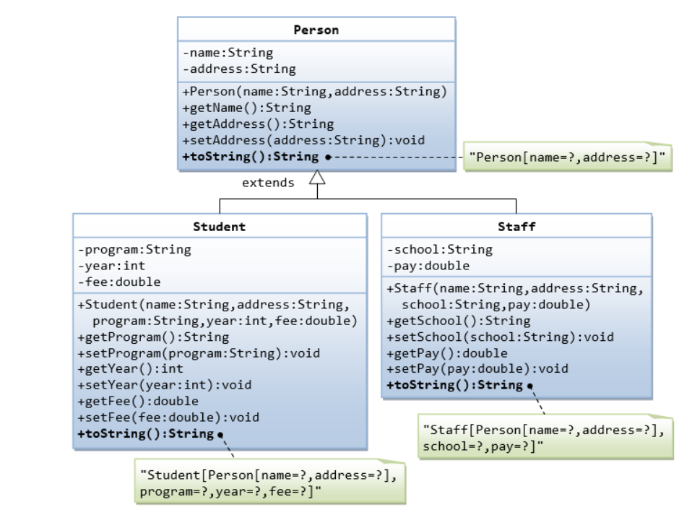

Team 3

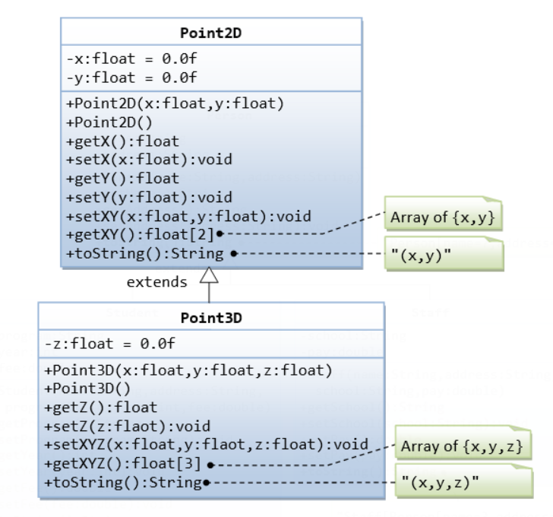

Team 4

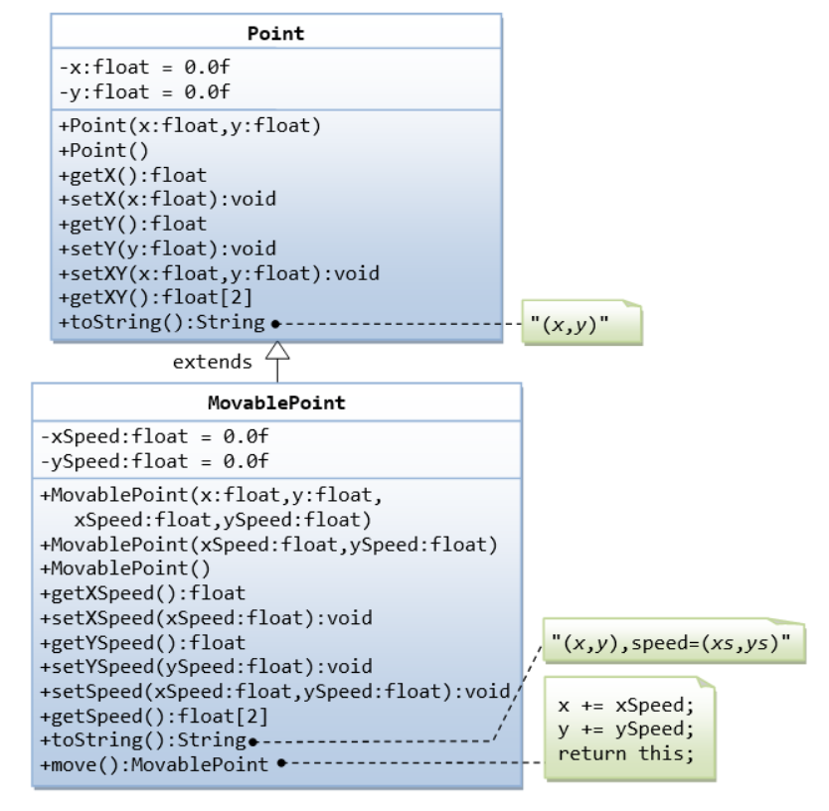

1. Write a program that illustrates method overriding. Class bond is extended by convertiblebond. Each of these classes defines a display() method that outputs the String “Bond” or “ConvertibleBond” respectively. Declare an array to hold six Bond objects. Initialize the elements of the array with a mix of Bond and convertible bond objects.

Team 5

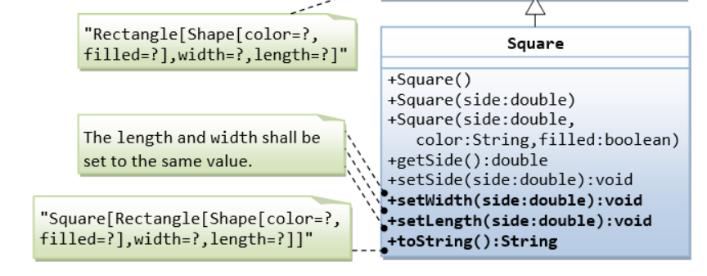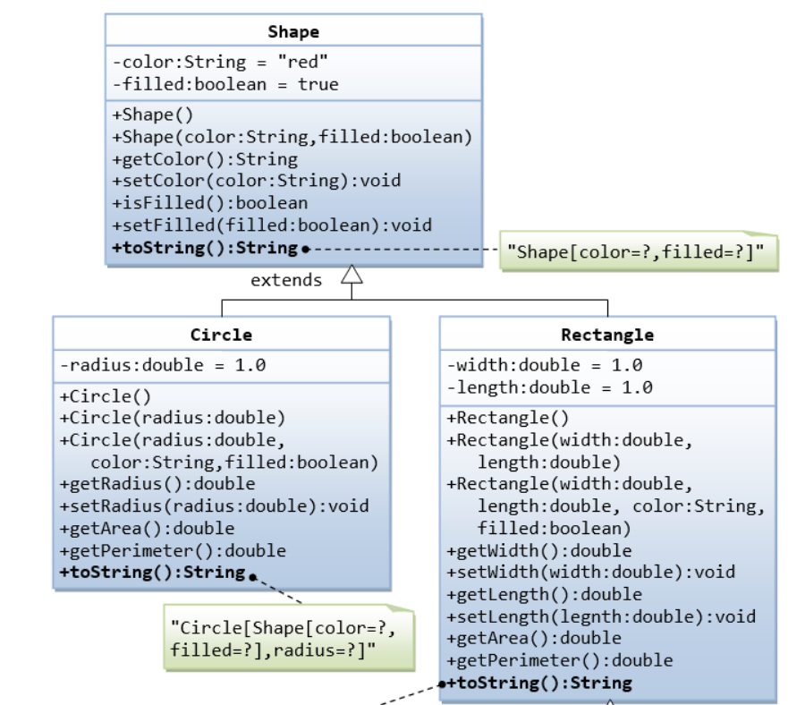 Team 6

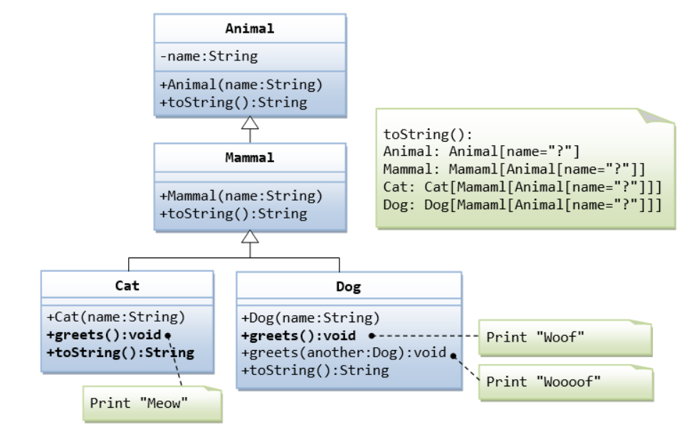

2. A boy has his money deposited $1000, $1500 and $2000 in banks-Bank A, Bank B and Bank C respectively. We have to print the money deposited by him in a particular bank.   
Create a class 'Bank' with a method 'getBalance' which returns 0. Make its three subclasses named 'BankA', 'BankB' and 'BankC' with a method with the same name 'getBalance' which returns the amount deposited in that particular bank. Call the method 'getBalance' by the object of each of the three banks.

Team 7

1. Develop a Java application with employee class includes emp_name, emp_id, address, mail_id, mobile_no as members.Inherit the classes Programmer, Assistant Professor from employee class.Add Basic Pay as the member of all the inherited classes with 97% of BP as DA, 10% of BP as HRA, 12% of BP as PF, 0.1% of BP for staff club fund. Generate the pay slips for the employees with their gross and net salary.
2. Create a class 'Degree' having a method 'getDegree' that prints "I got a degree". It has two subclasses namely 'Undergraduate' and 'Postgraduate' each having a method with the same name that prints "I am an Undergraduate" and "I am a Postgraduate" respectively. Call the method by creating an object of each of the three classes

Team 8

1. A software product is needed that store & retrieves information about automobiles. The information needed about all automobile is: maker(string), Vehicle identification number(string), Bluebookvalue(float), year (Integer), passengers(integer). Derive a class car from automobile. The fields are warranty-boolean, doors-int, imported-boolean, topspeed-integer, Size-String, rear door-String. Derive a class truck which have the following fields Topper-boolean, Wheels- String , Racks-Integer The product have to Display all information about all vehicles.
2. A boy has his money deposited $1000, $1500 and $2000 in banks-Bank A, Bank B and Bank C respectively. We have to print the money deposited by him in a particular bank.   
   Create a class 'Bank' with a method 'getBalance' which returns 0. Make its three subclasses named 'BankA', 'BankB' and 'BankC' with a method with the same name 'getBalance' which returns the amount deposited in that particular bank. Call the method 'getBalance' by the object of each of the three banks.